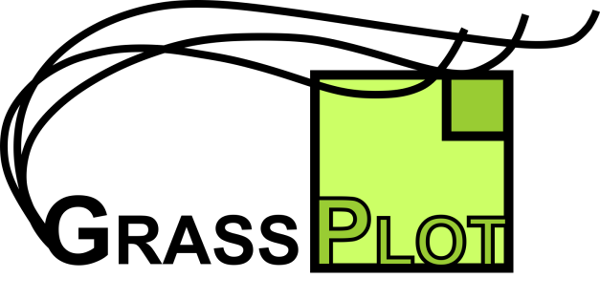
– Opt-in paper #<to be filled by GB> –
Project title (20 words maximum):
……..
Applicant(s) (names, affiliations and e-mail; underline first author and mark member(s) of the GrassPlot Consortium with *):
……..
Other already confirmed co-authors (names and affiliations; mark member(s) of the GrassPlot Consortium with * and provide reason for inclusion of non-members):
……..
Project description (aims and methods, 500 words maximum):
……..
Specification of data needed (e.g. concerning geographic area, plot sizes, compositional data, treatment of bryophytes/lichens; best consult with GrassPlot database manager before to check options):
……..
Request for additional data (if you are willing to consider in your paper additional data to be contributed via GrassPlot, please specify which type of data you are particularly searching, e.g. a geographic gap, and until when you would need to be notified):
……..
Envisaged publication(s) (number and target journals):
……..
Estimated time of delivery of results (e.g. manuscript submission):
……..
Co-authorship arrangement (from the GrassPlot Bylaws, Article 7):
Potential opt-in authors (those authors who have not already been listed by the applicant in the application), have to declare their interest to join as co-authors during the same 14-day period during which also the Dataset Custodians have to respond to data requests. Their declaration should contain a specification why they are interested in the particular paper project and what they could contribute, and should be sent to the Executive Committee. For the combined EDGG Field Workshop datasets, the Governing Board will nominate at maximum as many opt-in authors as such datasets are included in the request, based on expressed interests of the Workshop participants, taking into account their amount of contribution and how often they had been nominated in the past. Additionally, the Governing Board can nominate up to two opt-in authors from the Governing Board members or additional persons involved in the database management. For each other dataset that contributes at least 2% of the data of the particular study, the respective Dataset Custodian can nominate one of the data owners of the dataset as opt-in author. If someone is Dataset Custodian in several smaller datasets that together reach the 2% threshold, this is also accepted. The Executive Committee collects the information on proposed opt-in authors and will send them upon approval to the lead author of the publication for inclusion into the preliminary author list. Any other member of the GrassPlot Consortium not covered by the previous criteria (persons without data contribution or those whose data are not used in the particular study, data owners of datasets smaller than 2% or additional candidates from bigger datasets) can also apply to become opt-in author, but it is upon the discretion of the lead author(s) of the paper project whether they accept such an offer or not.
Generally, the lead author(s) of a paper project decide when and how to involve the approved opt-in authors. However, they are requested to provide all potential co-authors adequate opportunity and time to contribute. This means that outcomes should be shared with the full author team at least at three points of time, i.e. (i) when there is a concrete outline of the methodological approach, (ii) when there are the first results and (iii) at least two weeks before submission of a planned paper or presentation of the results on a conference. If a person preliminarily listed as opt-in author, despite requests from the lead author, has not made any intellectual contribution to the paper by the time of submission, the lead author should remove the respective name after consultation with the Governing Board. In case of dispute over authorship, both lead authors and opt-in authors can appeal to the Governing Board.
Confirmation:
I/we confirm that I/we will adhere to the GrassPlot Bylaws.
…………
(Date)

…………………………………………………………………………………………………………………………………
(Signature(s) of first author and of proponent from GrassPlot side (if different))

